Assessment Schedule – 2011

Science: Demonstrate understanding of aspects of mechanics (90940)

Evidence Statement
Question | Evidence |  |  | Achievement |  | Achievement with Merit |  | Achievement with Excellence
ONE  (a) | 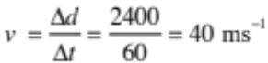 |  |  | - Calculates average speed.
(b) | Draw and label forces.  Forces acting are the weight downwards and air resistance upwards.  Weight is greater than air resistance when she has just jumped.  Net force  Net force is in the downwards direction and greater than zero.  Forces are unbalanced.  Explanation of motion  Motion is acceleration towards ground.  An unbalanced force is required to make an object’s speed change, therefore, as there is an unbalanced force greater than zero towards the ground, the parachutist’s speed will increase. |  |  | - Correct statement and / or diagram.  Eg:  Identifies two forces.  OR  Describes net force.  OR  Forces are unbalanced.  OR  Acceleration. |  | - Describes ONE force (weight / gravity) and explains why an unbalanced force situation exists.  - Describes TWO forces and explains why they are unbalanced.  - Describes TWO forces and explains why they are balanced (when parachutist is travelling at “terminal velocity”).  - Describes that unbalanced forces lead to acceleration |  | - Air resistance = 0N at the instant the parachutist leaves the plane. Acceleration at that instant will be 10ms⁻²  AND  - When falling her air resistance < weight / gravity, therefore unbalanced forces apply (net downward force) which causes acceleration (increase in speed).  Students must answer both to gain point.
(c) | The parachute has an increased surface area compared to parachutist on her own. This increases the size of the air resistance / friction / drag force acting in the upwards direction making it larger than the force of gravity. This creates an unbalanced force in the upwards direction (a negative net force), causing the parachutist to decelerate. |  |  | - Correct statement:  Increased surface area  OR  Unbalanced force acting. |  | - Explains effect of surface area (size and shape of parachute) on the forces involved (air resistance AND weight / gravity) . Needs to mention both forces.  OR  - That air resistance is slowing parachutist as net force is upwards. |  | - Explains the link between the increased surface area of parachute and the change to the forces involved (net force is upward), and how this reduces the speed of fall (deceleration).
 | Not achieved |  |  | Achievement |  | Achievement with Merit |  | Achievement with Excellence
Q1 | NØ = no evidence or no relevant evidence | N1 = correct idea. Eg correct unit | N2 = 1 point from Achievement | A3 = 2 points | A4 = 3 points | M5 = 2 points | M6 = 3 points | E7 = 1 point | E8 = 2 points

Question | Evidence | Achievement | Achievement with Merit | Achievement with Excellence
TWO  (a) | F = ma  = 60 × 0.2 = 12 N | - Calculates F with unit.
(b) | W = Fd  = 12 × 12.5 = 150 J  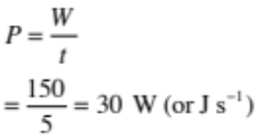  Possible follow-on error from 2(a). | - Calculates either  W correct.  OR  P using an incorrect value for W, which has not been calculated. | - Calculates Power done, but:  EITHER  Does not give a unit.  OR  Gives an incorrect value of P using a calculated value of W. | - Calculates power and gives an appropriate unit.
(c) | 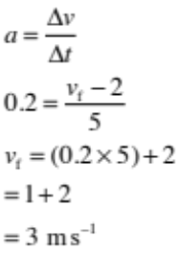  OR  By reasoning (formula not required), ie 5 s at 0.2 m s^{–2}  Increase in speed = 1 m s^{–2}  Started at 2 m s^{–1}  now at 3 m s^{–1}.  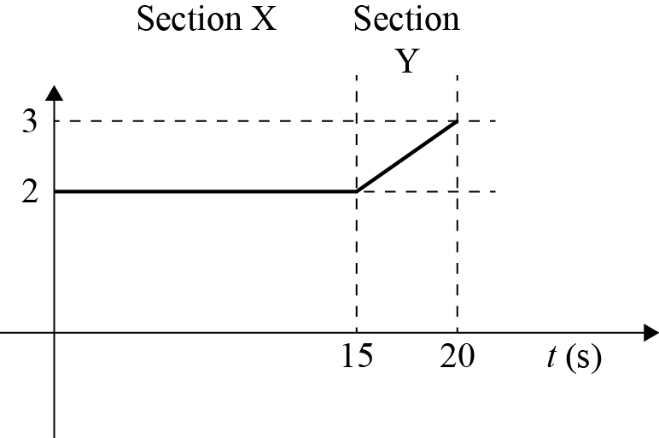 | - Has correct shapes for sections X or Y on graph, but no values on y-axis. | - Either  Calculates v_{f} correctly.  OR  Shows correct value (3) on y-axis but graph is incorrect.  - Calculated v_{f} incorrectly but showed 1m s^{–1} increase using acceleration.  - Showed correct shapes for sections X and Y. | - Graph with correct values on y-axis and correct shapes for sections X and Y.

 | Not achieved |  |  | Achievement |  | Achievement with Merit |  | Achievement with Excellence
Q2 | NØ = no evidence or no relevant evidence | N1 = correct formula not correctly used OR correct unit. | N2 = 1 point from Achievement | A3 = 2 points | A4 = 3 points | M5 = 2 points | M6 = 3 points | E7 = 1 point | E8 = 2 points

Question | Evidence |  |  | Achievement |  | Achievement with Merit |  | Achievement with Excellence
THREE  (a) | E_{P} = mgΔh  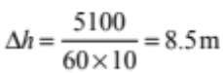 |  |  | - Correctly calculated height.  Unit not necessary. |  | - Correctly calculated height.  Unit necessary
(b) | Name of energy  Gravitational potential energy.  Calculation of work  W = Fd = 60 × 10 × 8 = 4 800 J  OR  W = E_{P} = mgΔh = 60 × 10 × 8 = 4 800 J  Calculation of difference  Work done is energy gained,  so energy difference = 5 100 – 4 800 = 300J  Explanation of difference  The difference is due to energy being converted into heat in the muscles of her body. |  |  | - Identifies type of energy at the top.  - Correct calculation of work.  - Energy difference calculated (allow error in work calculation) but no reference to work equals energy.  - Heat is produced. |  | - Identifies type of energy at the top and states that energy is changed to heat.  - Correct calculation of work and correct calculation of energy difference.  - Correct calculation of energy difference (allow consequential error) AND work stated to be equal to energy changed. |  | - Work correctly calculated and stated to be the same as the gravitational potential energy changed / gained. Energy difference correctly calculated.  - Some of the energy used is changed to heat by the muscles of the girl’s body, and so the gravitational potential energy she gains is less than the total energy that she uses.
 | Not achieved |  |  | Achievement |  | Achievement with Merit |  | Achievement with Excellence
Q3 | NØ = no evidence or no relevant evidence | N1 = correct formula not correctly used | N2 = 1 correct point from Achievement | A3 = 2 points | A4 = 3 points | M5 = 2 points | M6 = 3 points | E7 = both points attempted, but some minor inconsistencies or omissions | E8 = both points fully answered

Question | Evidence | Achievement | Achievement with Merit | Achievement with Excellence
FOUR  (a) | F = mg = 40 × 10 = 400 N  For boot without studs  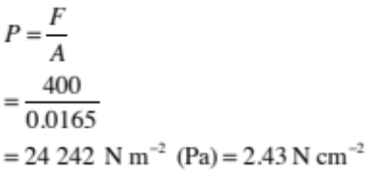  For boot with studs  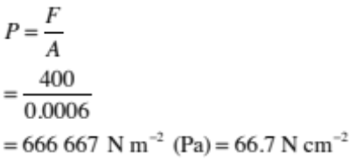 | - Calculates  Weight force.  OR  Pressure incorrectly using  F = 40 | - Calculates pressure for one of boots. | - Calculates pressures of both, with correct unit.
(b) | Comparison  The pressure exerted by the boot with studs is greater than the boot without studs.  Relationship  The smaller the surface area (the force is exerted over), the greater the pressure exerted on the ground.  How it helps on grass  As the student’s weight is applied over a smaller surface area with the boots with studs, it leads to a greater pressure on the ground. This means that the studs will sink into the ground more, which will enable the student to get a better grip / traction on grass when running. | - States correct pressure comparison.  Eg, states smaller surface area leads to greater pressure or visa versa.  - States correct effects comparison  Eg, states studs will sink into ground more or states studs will give better grip. | - Explains the relationship between surface area and pressure with respect to studded and non-studded boots.  OR  - Shows understanding of physics principles involved by identifying greater pressure leads to boots sinking into grass. | - Links greater pressure created by smaller area of studs to more grip / traction when running on grass.  - Comparison with the other boot without stud is provided (ie smaller pressure created by larger area of shoe leads to slipping / loss of friction.)

 | Not achieved |  |  | Achievement |  | Achievement with Merit |  | Achievement with Excellence
Q4 | NØ = no evidence or no relevant evidence | N1 = correct unit  OR  correct equation  F = mg, but incorrect calc | N2 = 1 point from Achievement | A3 = 2 points | A4 = 3 points | M5 = 1 point | M6 = 2 points | E7 = 2 point | E8 = 3 points

Judgement Statement
 | Not Achieved | Achievement | Achievement  with Merit | Achievement  with Excellence
Score range | 0 – 10 | 11 – 19 | 20 – 24 | 25 – 32

